**CMPE 202 - Project Journal**

**Airline System**

**1) Team Members**

Nidhi Tholar Kuchur – 014738776 ([nidhi.tholarkuchur@sjsu.edu](mailto:nidhi.tholarkuchur@sjsu.edu))

Sameer Joshi – 015219308 ([sameeranil.joshi@sjsu.edu](mailto:sameeranil.joshi@sjsu.edu))

Abhishek Reddy – 015489240 ([abhishek.isireddy@sjsu.edu](mailto:abhishek.isireddy@sjsu.edu))

Sai Kapadekar – 015937727 ([saimahendra.kapadekar@sjsu.edu](mailto:saimahendra.kapadekar@sjsu.edu))

**2) Tech Stack and Tools**

Stack – Python, Flask, MongoDB, React

Project Board – GitHub

Sprint Task Sheet – Google Sheets

Burn Down Charts – Google Sheets

Wireframes – Figma

Cloud Infrastructure – AWS

API Testing – Postman

**3) Installation and Setup (Sai)**

**4) Cloud Implementation (Sai)**

**5) XP Values (Sai)**

**6) Project Board**

<https://github.com/gopinathsjsu/team-project-team_techies/projects?query=is%3Aclosed>

<https://github.com/gopinathsjsu/team-project-team_techies/issues?q=is%3Aissue+is%3Aclosed>

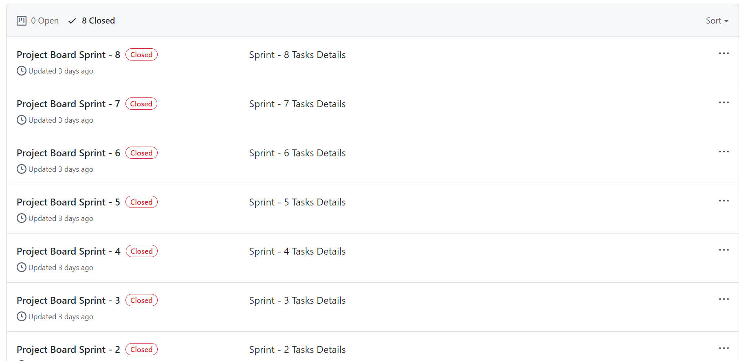

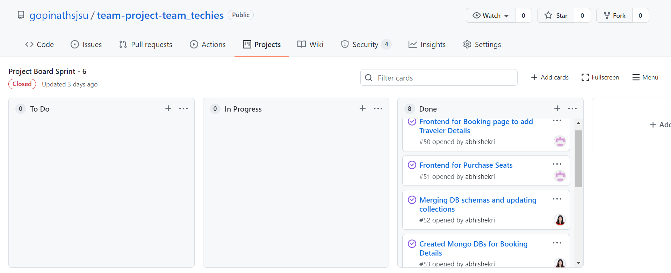

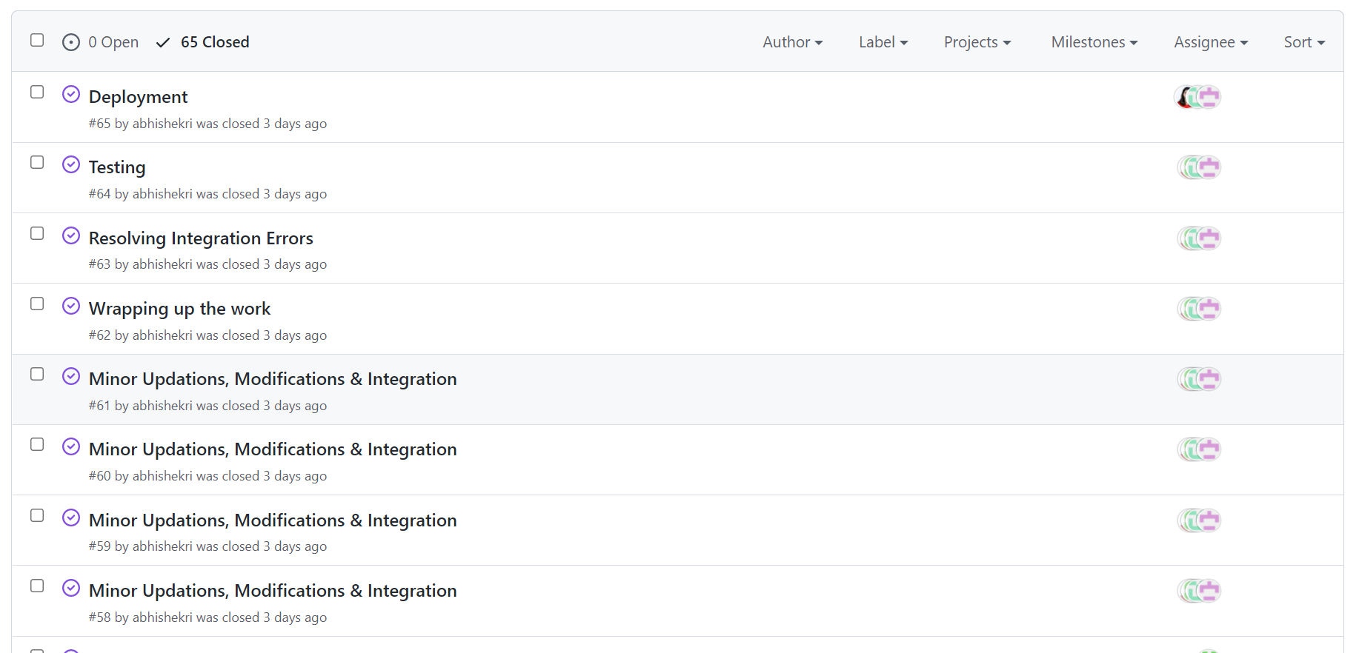

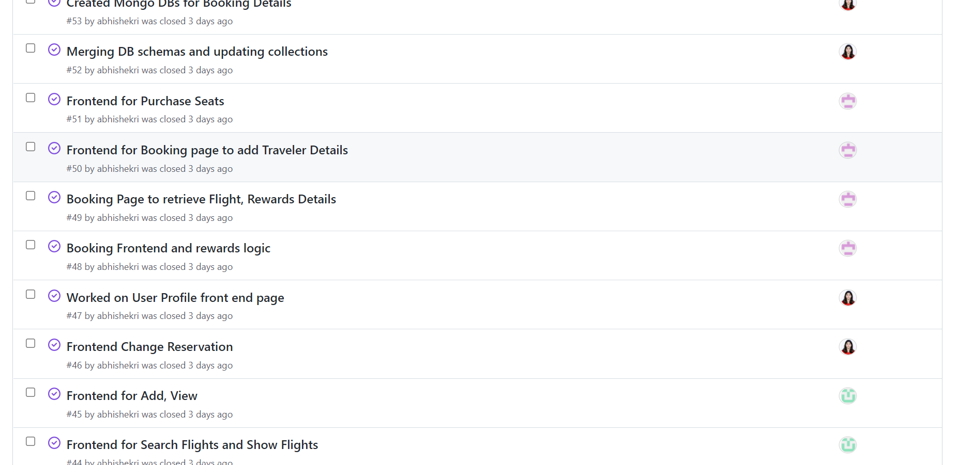

**4) Database Design (Sai)**

**5) Class Diagram**

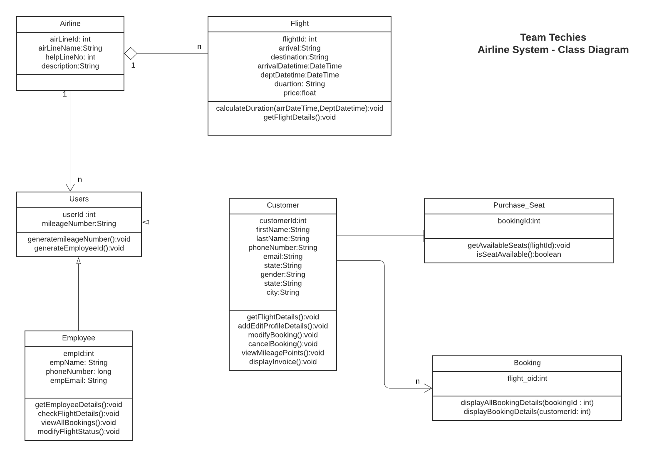

**6) Architecture Diagram**

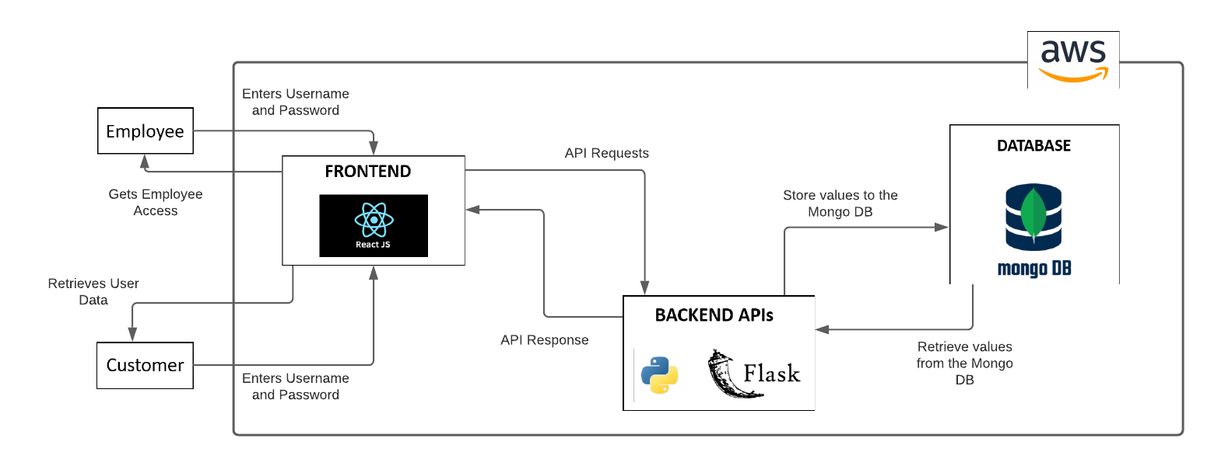

**6) Task Sheet and Burn Down Charts**

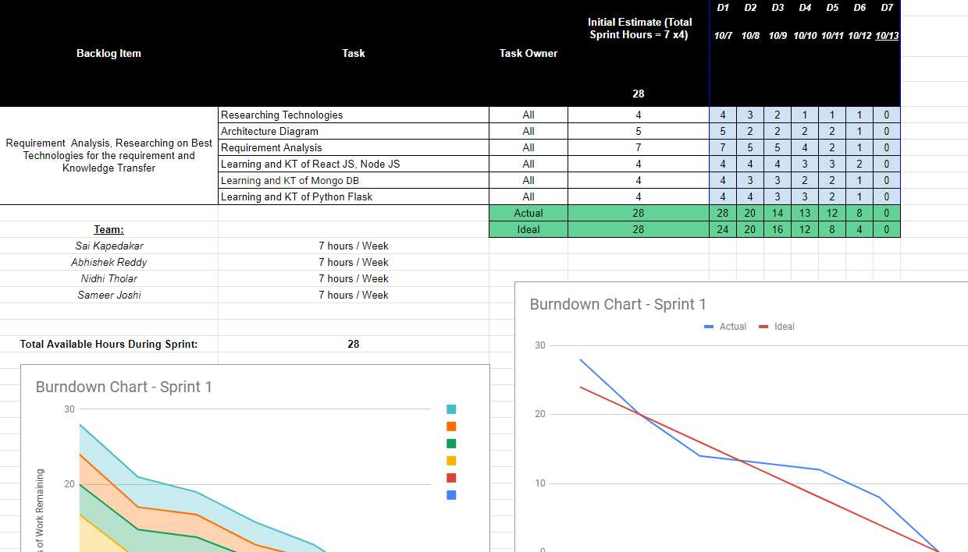<https://docs.google.com/spreadsheets/d/1ygpydfTKiJSf9sMSvin8N8VKZnjJtatqK-yY7swSfHY/edit?usp=sharing>

**8) Retrospective Sprint Sheet**

<https://docs.google.com/spreadsheets/d/1qkVE57TqKiTPVYwF8EKbHxaOOvGZFEhWTGasEablBwI/edit?usp=sharing>

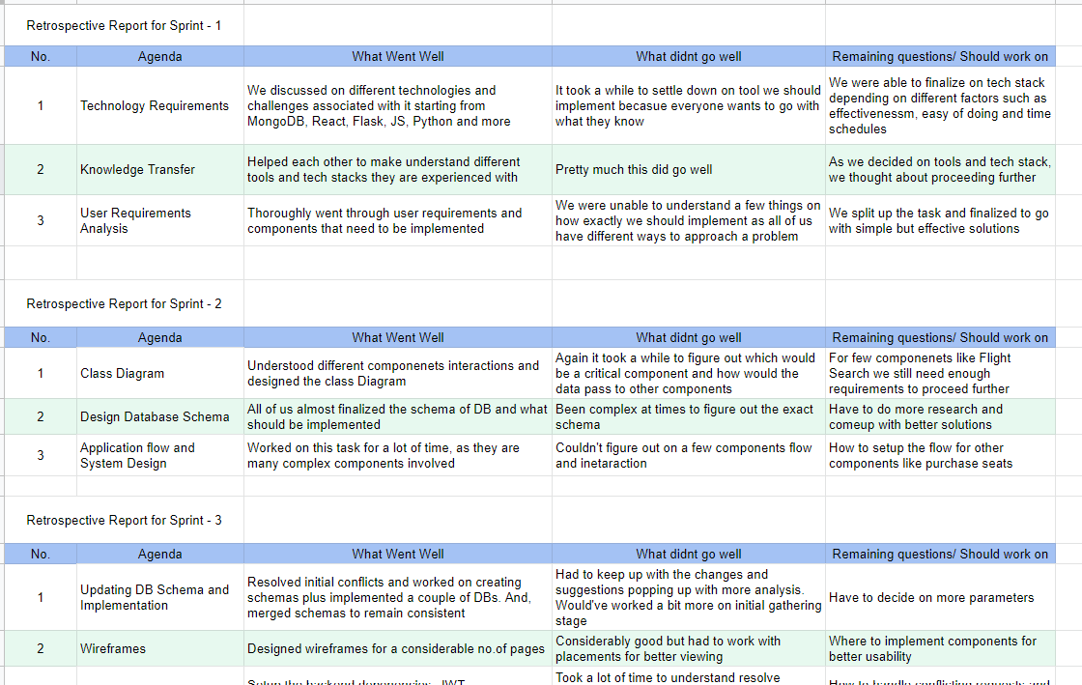

9) Individual Weekly Scrum

*Abhishek Reddy*

<https://docs.google.com/spreadsheets/d/1_aHNmTuNIYFgEyqz5o2FzVLN7aCttFjf59oA6MB923c/edit?usp=sharing>

